# Applecross Senior High School

### Semester One Examination, 2019

### Question/Answer booklet

# MATHEMATICS

**SOLUTIONS**

**METHODS**

**UNIT 1**

## Section One:

## Calculator-free

|  |  |  |  |  |  |  |  |  |  |  |
| --- | --- | --- | --- | --- | --- | --- | --- | --- | --- | --- |
| Student number: In figures |  |  |  |  |  |  |  |  |  |  |

In words

Your name

## Time allowed for this section

Reading time before commencing work: five minutes

Working time: fifty minutes

## Materials required/recommended for this section

***To be provided by the supervisor***

This Question/Answer booklet

Formula sheet

***To be provided by the candidate***

Standard items: pens (blue/black preferred), pencils (including coloured), sharpener,  
correction fluid/tape, eraser, ruler, highlighters

Special items: nil

## Important note to candidates

No other items may be taken into the examination room. It is **your** responsibility to ensure that you do not have any unauthorised material. If you have any unauthorised material with you, hand it to the supervisor **before** reading any further.

## Structure of this paper

|  |  |  |  |  |  |
| --- | --- | --- | --- | --- | --- |
| Section | Number of questions available | Number of questions to be answered | Working  time (minutes) | Marks available | Percentage of examination |
| Section One:  Calculator-free | 8 | 8 | 50 | 52 | 35 |
| Section Two:  Calculator-assumed | 13 | 13 | 100 | 98 | 65 |
|  | | |  | **Total** | 100 |

## Instructions to candidates

1. The rules for the conduct of examinations are detailed in the school handbook. Sitting this examination implies that you agree to abide by these rules.

2. Write your answers in this Question/Answer booklet preferably using a blue/black pen.  
Do not use erasable or gel pens.

3. You must be careful to confine your answer to the specific question asked and to follow any instructions that are specified to a particular question.

4. Show all your working clearly. Your working should be in sufficient detail to allow your answers to be checked readily and for marks to be awarded for reasoning. Incorrect answers given without supporting reasoning cannot be allocated any marks. For any question or part question worth more than two marks, valid working or justification is required to receive full marks. If you repeat any question, ensure that you cancel the answer you do not wish to have marked.

5. It is recommended that you do not use pencil, except in diagrams.

6. Supplementary pages for planning/continuing your answers to questions are provided at the end of this Question/Answer booklet. If you use these pages to continue an answer, indicate at the original answer where the answer is continued, i.e. give the page number.

7. The Formula sheet is not to be handed in with your Question/Answer booklet.

Section One: Calculator-free 35% (52 Marks)

This section has**eight (****8)** questions. Answer **all** questions. Write your answers in the spaces provided.

Working time: 50 minutes.

Question 1 (7 marks)

(a) Solve the following equations for $x$.

(i) $\left(2x-9\right)\left(x+7\right)=0$. (1 mark)

|  |
| --- |
| **Solution** |
| $$x=4.5, x=-7$$ |
| **Specific behaviours** |
| ✓ both correct solutions |

(ii) $\begin{matrix}x \\ \overline{3}\end{matrix}=\begin{matrix}2x-1 \\ \overline{ 2 }\end{matrix}$. (2 marks)

|  |
| --- |
| **Solution** |
| $$2x=6x-3$$ $$4x=3⇒x=\frac{3}{4}$$ |
| **Specific behaviours** |
| ✓ cross multiplies  ✓ correct solution |

(iii) $4x^{2}=4x$. (2 marks)

|  |
| --- |
| **Solution** |
| $$4x\left(x-1\right)=0$$ $$x=0, x=1$$ |
| **Specific behaviours** |
| ✓ one correct solution  ✓ both correct solutions |

(b) (i) What are the coordinates of the -intercept of the graph of ?

|  |
| --- |
| **Solution** |
| $$x=0, y=-6 (0, -6)$$ |
| **Specific behaviours** |
| ✓ correct solutions |

(1 mark)

|  |
| --- |
| **Solution** |
| $$None, as the parabola has a minimum Turning Point at (0, 1)$$ |
| **Specific behaviours** |
| ✓ correct solutions |

(ii) State the number of x-intercepts the graph of . (1 mark)

Question 2 (6 marks)

(a) A circle of radius $4$ has its centre at the point $(-2, 3)$. Determine the equation of the circle in the form $x^{2}+y^{2}=ax+by+c$. (3 marks)

|  |
| --- |
| **Solution** |
| $${\left(x+2\right)}^{2}+{\left(y-3\right)}^{2}=4^{2}$$ $$x^{2}+4x+4+y^{2}-6y+9=16$$ $$x^{2}+y^{2}=-4x+6y+3$$ |
| **Specific behaviours** |
| ✓ writes equation of circle  ✓ correctly expands  ✓ writes in required form |

(b) The graph of $x=y^{2}$ passes through the point $(4, q)$. Determine the value(s) of $q$ and hence explain why $y$ is a relation but not a function of $x$. (3 marks)

|  |
| --- |
| **Solution** |
| $$4=q^{2}⇒q=±2$$ A relation exists as we are told that $x=y^{2}.$ The relation is not a function because it is not one-to-one (for most values of $x$ there is more than one value of $y$). |
| **Specific behaviours** |
| ✓ both possible values  ✓ explains relation between variables  ✓ explains why relation not a function |

Question 3 (6 marks)

(a) The graph of $y=a\cos{(x+b)}$ is shown below, where $a$ and $b$ are constants.

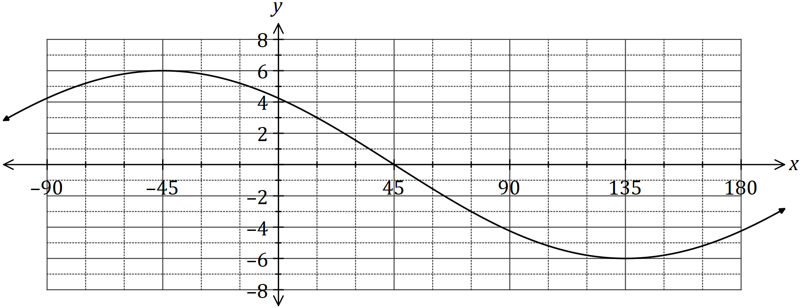

Determine the value of $a$ and the value of $b$, where $-90°≤b≤180°$. (2 marks)

|  |
| --- |
| **Solution** |
| $$a=6, b=45$$ |
| **Specific behaviours** |
| ✓ value of $a$ ✓ value of $b$ |

(b) Given that $0°≤x≤360°$, solve

(i) $\cos{(x)}=\frac{1}{2}$. (1 mark)

|  |
| --- |
| **Solution** |
| $$x=60°, 300°$$ |
| **Specific behaviours** |
| ✓ correct solutions |

(ii) $8\cos{(x+30°)}+4\sqrt{3}=0$. (3 marks)

|  |
| --- |
| **Solution** |
| $$\cos{(x+30°)}=-\frac{\sqrt{3}}{2}$$ $$x+30°=150°, 210°$$ $$x=120°, 180°$$ |
| **Specific behaviours** |
| ✓ simplifies equation  ✓ solves for angle sum  ✓ correct solutions |

Question 4 (7 marks)

(a) Determine the **coordinates** of the

(i) $y$-intercept of the graph of $y=4{\left(x-3\right)}^{2}-26$. (1 mark)

|  |
| --- |
| **Solution** |
| $$x=0, y=4{\left(-3\right)}^{2}-26=36-26=10$$ $$\text{At} (0, 10)$$ |
| **Specific behaviours** |
| ✓ correct coordinates |

(ii) turning point of the graph of $y=(x+4)(x-2)$.

(2 marks)

|  |
| --- |
| **Solution** |
| $$x=\left(-4+2\right)÷2=-1$$ $$y=\left(-1+4\right)\left(-1-2\right)=-9$$ $$\text{At} \left(-1, -9\right)$$ |
| **Specific behaviours** |
| ✓ correct $x$-coordinate  ✓ correct $y$-coordinate |

(b) The graph of $y=ax^{2}+bx+c$ is shown below. Determine the value of the coefficients $a, b$ and $c$. (4 marks)

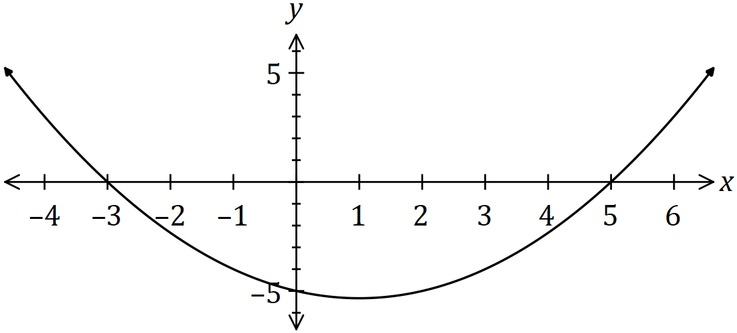

|  |
| --- |
| **Solution** |
| $$y=a\left(x+3\right)\left(x-5\right)$$ $$-5=a\left(3\right)\left(-5\right)⇒a=\frac{1}{3}$$ $$y=\frac{1}{3}\left(x^{2}-2x-15\right)$$ $$a=\frac{1}{3}, b=-\frac{2}{3}, c=-5$$ |
| **Specific behaviours** |
| ✓ uses roots to write in factored form  ✓ uses $y$-intercept to determine $a$ ✓ expands quadratic  ✓ states all coefficients |

Question 5 (7 marks)

(a) Expand $x{\left(x+4\right)}^{2}$. (2 marks)

|  |
| --- |
| **Solution** |
| $$x\left(x^{2}+8x+16\right)=x^{3}+8x^{2}+16x$$ |
| **Specific behaviours** |
| ✓ expands quadratic correctly  ✓ correct expansion |

(b) Let $f\left(x\right)=x^{3}+2x^{2}-5x-6$.

(i) Determine $f(2)$. (1 mark)

|  |
| --- |
| **Solution** |
| $$f\left(2\right)=2^{3}+2{\left(2\right)}^{2}-5\left(2\right)-6 \\ =8+8-10-6 \\ =0$$ |
| **Specific behaviours** |
| ✓ correct value |

(ii) Solve $f\left(x\right)=0$. (4 marks)

|  |
| --- |
| **Solution** |
| $$x^{3}+2x^{2}-5x-6=\left(x-2\right)\left(x^{2}+bx+3\right)$$ $$-5x=-2bx+3x⇒b=4$$ $$x^{2}+4x+3=\left(x+3\right)\left(x+1\right)$$ $$\left(x-2\right)\left(x+3\right)\left(x+1\right)=0⇒x=-3, -1, 2$$ |
| **Specific behaviours** |
| ✓ uses (a) to write cubic as linear and quadratic factor  ✓ determines entire quadratic factor  ✓ factorises quadratic  ✓ all correct solutions |

Question 6 (7 marks)

(a) Briefly describe the behaviour of the $y$ values for each of the following graphs, given the behaviour of the $x$ values:

(i) $y=x^{4}$, as $x→∞$. (1 mark)

|  |
| --- |
| **Solution** |
| $$y→∞$$ |
| **Specific behaviours** |
| ✓ describes correct behaviour |

(ii) $y={\left(2-x\right)}^{3}$, as $x→∞$. (1 mark)

|  |
| --- |
| **Solution** |
| $$y→-∞$$ |
| **Specific behaviours** |
| ✓ describes correct behaviour |

(iii) $y=\begin{matrix}1 \\ \overline{x}\end{matrix}$, as $x→-∞$. (1 mark)

|  |
| --- |
| **Solution** |
| $$y→0$$ |
| **Specific behaviours** |
| ✓ describes correct behaviour |

(b) The graph of $y=f(x)$ is shown below. On the same axes sketch the graph of

(i) $y=f(x+3)$. (2 marks)

(ii) $y=f(3x)$. (2 marks)

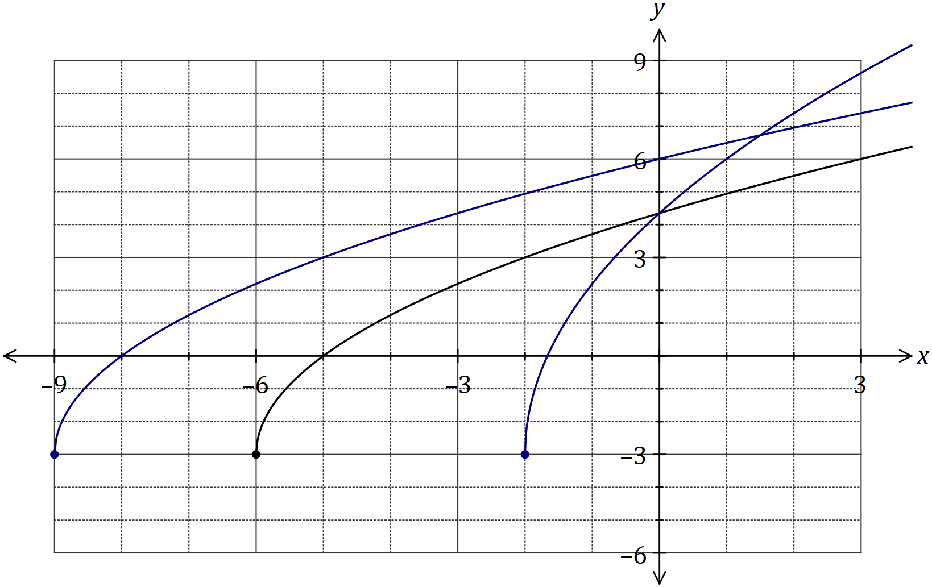

|  |
| --- |
| **Solution (ii)** |
| See graph |
| **Specific behaviours** |
| ✓ smooth curve starting at $(-2, -3)$ ✓ same $y$-intercept as |

|  |
| --- |
| **Solution (i)** |
| See graph |
| **Specific behaviours** |
| ✓ smooth curve starting at $(-9, -3)$ ✓ intercepts at $(-8, 0)$ and $(0, 6)$ |

Question 7 (7 marks)

Line $L$ has equation $\begin{matrix}x \\ \overline{4}\end{matrix}+\begin{matrix}y \\ \overline{5}\end{matrix}=1$.

(a) State the coordinates of the point where $L$ intersects the $x$-axis. (1 mark)

|  |
| --- |
| **Solution** |
| $$y=0⇒x=4$$ $$\text{At} (4, 0)$$ |
| **Specific behaviours** |
| ✓ correct coordinates |

(b) State, with justification, if $L$ is parallel to the line with equation $y=0.8x+1$. (2 marks)

|  |
| --- |
| **Solution** |
| $$y=5-\frac{5}{4}x$$ $L$ is not parallel to this line as the gradients are different: $-\frac{5}{4}≠0.8$. |
| **Specific behaviours** |
| ✓ indicates gradient of $L$ ✓ states not parallel, comparing gradients |

(c) Determine the equation of line $P$ that is perpendicular to $L$ and passes through the point with coordinates $(50, 4)$. (2 marks)

|  |
| --- |
| **Solution** |
| $$y=\frac{4}{5}x+c$$ (50, 4)⇒ $y=\frac{4}{5}x-36$ |
| **Specific behaviours** |
| ✓ indicates perpendicular gradient  ✓ correct equation |

(d) Determine the coordinates of the point of intersection of $L$ and $P$. (2 marks)

|  |
| --- |
| **Solution** |
| $$P:y=\frac{4}{5}x-36$$ $$\frac{4}{5}x-36=5-\frac{5}{4}x⇒\frac{41}{20}x=41⇒x=20$$ $$y=\frac{4}{5}\left(20\right)-36=-20$$ $$\text{Intersect at} (20, -20)$$ |
| **Specific behaviours** |
| ✓ equates equations and solves for $x$ ✓ correct coordinates |

Question 8 (5 marks)

(a) Evaluate $\sin\left(\begin{matrix}39π \\ \overline{ 4 }\end{matrix}\right)$. (2 marks)

|  |
| --- |
| **Solution** |
| $$\sin{\frac{39π}{4}}=\sin{\frac{\left(39-32\right)π}{4}}=\sin{\frac{7π}{4}}$$ $$\sin{\frac{7π}{4}}=-\sin{\frac{π}{4}}=-\frac{1}{\sqrt{2}}=-\frac{\sqrt{2}}{2}$$ |
| **Specific behaviours** |
| ✓ reduces angle  ✓ exact value |

(b) $A$ is an acute angle and $B$ is an obtuse angle such that $\cos{A}=\begin{matrix}1 \\ \overline{3}\end{matrix}$ and $\sin{B}=\begin{matrix}2 \\ \overline{3}\end{matrix}$.

Show that $\sin{A}=\begin{matrix}2\sqrt{2} \\ \overline{ 3 }\end{matrix}$ and determine the value of $\cos{B}$. (3 marks)

|  |
| --- |
| **Solution** |
| $$\sin^{2}{A}=1-{\left(\frac{1}{3}\right)}^{2}=\frac{8}{9}⇒\sin{A}=\frac{\sqrt{8}}{3}=\frac{2\sqrt{2}}{3}$$ $$\cos^{2}{B}=1-{\left(\frac{2}{3}\right)}^{2}=\frac{5}{9}$$ $$\cos{B}=-\frac{\sqrt{5}}{3}$$ |
| **Specific behaviours** |
| ✓ indicates how to obtain  ✓ obtains $\cos^{2}{B}$ ✓ correct value of $\cos{B}$ |

Supplementary page

Question number: _________

© 2019 WA Exam Papers. Applecross Senior High School has a non-exclusive licence to copy and communicate this document for non-commercial, educational use within the school. No other copying, communication or use is permitted without the express written permission of WA Exam Papers. SN002-132-2.